# Amazing Maze Game

We are going to make a maze. The maze will have a ball that you can move, and you have to move the ball to the goal to win the game. This is what it will look like:

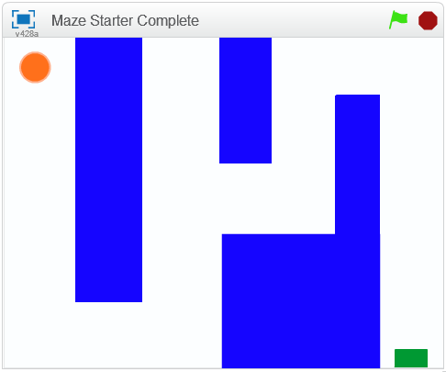

## Import the Stage

Start by importing (or uploading) the blue maze state. It is called **backdrop\_maze**.



## Import the sprites

There are two sprites to upload. They are:

* ball\_costume
* goal\_costume

C:\Users\Jason\Documents\Personal\CodeClub\Resources\Scratch Term 1\Maze - week 3\ball_costume.pngC:\Users\Jason\Documents\Personal\CodeClub\Resources\Scratch Term 1\Maze - week 3\goal_costume.png

You will be given the stage and the sprite costume files to import.

## Position the Ball

When you start the game by clicking on the green flag, the ball needs to move to the start of the maze. The start is in the top left corner.

Add this script to the call sprite to position it at the start of the game:

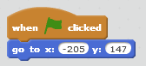

## Move the Ball

You will want to be able to move the ball around using the arrow keys. The scripts below, added to the ball sprite, will allow you to move the ball.

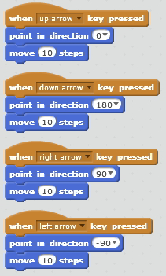

Each of the four arrow keys, when pressed, will change the direction of the ball, then move it by ten steps in that direction.

Can you make the ball move slower? Can you make it move faster?

## Bounce off the Walls

When you move the ball into a wall, what happens? Should the ball go through the wall like this?

To stop the ball taking a short-cut over the walls, we can use sensing. We will add a script that will make the ball bounce backwards by ten steps each time it hits a blue wall. Here is the script:

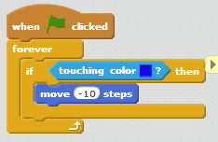

Add this script to the ball sprite, as before.

## Reaching the Goal

What happens when you reach the goal? Nothing? We can change that.

We will add a script to the goal, so that when the ball touches it, the goal tells you that you have won. This script, added to *the goal* (not the ball) will do that:

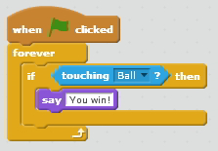

## The Finished Game

Now you should have a finished game. You can start the ball in the top left, and move it through the maze to the goal in the bottom right. When you get to the goal, you are told, “You have won!”.

## Extras

What else can you do to this game? What is missing from it? Here are some suggestions:

* Play a sound each time you hit a wall.
* Play a different sound when you reach the goal.
* Use a different sprite costume. Be careful not to make it too big.
* Paint a different maze backstage.